CSA1413
COMPILER DESIGN
Name: Haresh Kumar N L
Reg No: 192425009
Bottom-Up Evaluation of S-Attributed Syntax-Directed Definition

Aim:
To write a C program to perform bottom-up evaluation of an S-attributed syntax-directed definition for the given grammar and evaluate the arithmetic expression to display its final value.

Algorithm:
- Start the program.
- Include the required header files.
- Declare an expression array and an integer stack.
- Read the arithmetic expression from the user.
- Scan the expression character by character.
- Identify numeric values and convert them into integers.
- Push each number onto the stack according to the production T → num.
- Ignore the addition operator while scanning the expression.
- Perform bottom-up evaluation by adding the stack elements according to E → E + T.
- Display the final evaluated value of E.
- Stop the program.

Pseudocode:
BEGIN
Declare expression array
Initialize stack and top = -1
Read arithmetic expression
WHILE expression is not empty DO
IF current character is a digit THEN
Initialize num = 0
WHILE current character is a digit DO
Convert character into integer
Build the number
Move to next character
END WHILE
Push number onto stack
ELSE IF current character is '+' THEN
Move to next character
ELSE
Print "Invalid expression"
EXIT
END IF
END WHILE
WHILE stack contains more than one element DO
Pop T from stack
Add T to E
Store the result in stack
END WHILE
Print "Value of E" and final result
END

Code:
#include <stdio.h>
#include <ctype.h>
#include <stdlib.h>
int main()
{
char exp[100];
int stack[100];
int top = -1;
int i = 0, num;
printf("Enter expression: ");
if (fgets(exp, sizeof(exp), stdin) == NULL)
{
printf("Input error!\n");
return 1;
}
while (exp[i] != '\0')
{
if (isspace((unsigned char)exp[i]))
{
i++;
}
else if (isdigit((unsigned char)exp[i]))
{
num = 0;
while (isdigit((unsigned char)exp[i]))
{
num = num * 10 + (exp[i] - '0');
i++;
}
stack[++top] = num;
}
else if (exp[i] == '+')
{
i++;
}
else
{
printf("Invalid expression!\n");
return 1;
}
if (top >= 99)
{
printf("Expression too long!\n");
return 1;
}
}
if (top == -1)
{
printf("Invalid expression!\n");
return 1;
}
while (top > 0)
{
int t = stack[top--];
int e = stack[top];
stack[top] = e + t;
}
printf("Value of E = %d\n", stack[top]);
return 0;
}

Input:
5 + 6

Output:
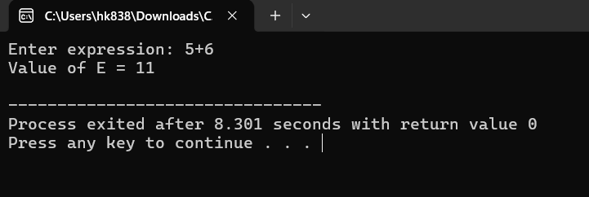
Result:
Thus, the C program to perform bottom-up evaluation of an S-attributed syntax-directed definition and evaluate the given arithmetic expression was executed successfully.

